System Requirements Specifications Process

Process Policy

- When complete requirements are not provided by the client the same will be elicited.
- Gaps in requirement specified by the client identified against the SRS template are documented.
- The SRS will be reviewed by the Stakeholders
- The project will seek approval from the client, for SRS and changes to requirements
- Traceability Matrix will be developed to track client specified requirements to deliverables. This will be updated with changes to requirements
All Rights Reserved

This document is a property of Trianz. No part of this document may be copied or reproduced in any form or by any means, electronic, mechanical or otherwise without the prior written permission of Trianz.

Owner: S Bala Raja | RID: QMS/5101/0207
Email: qmg@trianz.com | Version: 11.00
Date: 21-Apr-06 | Total Pages: 10
Distribution List: All employees of Trianz

3rd Floor, Hulkul Brigade Centre
# 82, Lavelle Road
Bangalore – 560 001

Phone: +91-80-22127870
E-mail: contactus@trianz.com

Table of Contents
System Requirements Specifications Process 1
1 Introduction 3
1.1. Definitions/Acronyms/Abbreviations 3
1.2. Objectives 3
1.3. Scope 3
1.4. Roles and Responsibilities 3
1.5. Prerequisites 3
1.1.1 Resource 3
1.1.2 Training 4
1.6. References 4
2 Entry Criteria 4
3 Inputs 4
4 Process Flow 5
5 Process Description 6
1.7. Requirements Elicitation 6
1.8. Requirements Specification 7
1.9. Traceability Matrix 7
1.10. SRS Review and approval 7
1.11. Changes to SRS 7
6 Outputs 8
1.12. Deliverables 8
1.13. Quality Records 8
7 Exit Criteria 8
8 Process Assets 8
9 Measurement 8
10 Tailoring Guidelines 8
11 Standards Addressed 9
Appendix 10
Revision History 10

Introduction
The System Requirements Specification (SRS) document is intended to capture all User requirements – functional and non-functional for the project/product.

Definitions/Acronyms/Abbreviations
Term | Description
SRS | System Requirements Specification
PM | Project Manager
SOW | Statement of Work
CCB | Change Control Board
QMG | Quality Management Group
RFP | Request for Proposal
CR | Change Request

Objectives
To establish a common understanding between the Client and the development team regarding the complete requirements of the project.

Scope
The process scope covers Requirement elicitation and Requirements specification

Roles and Responsibilities
Role | Responsibility | Internal/External
Project Manager | - Identify the stakeholders for the SRS  - Form Requirements Gathering and Requirements Analysis teams and manage these activities/teams  - Coordinate development and review of SRS internally and with the Client  - Get Client approval of SRS  - Manage changes to SRS | Internal
Requirements Elicitation Team | - Elicit and document Client requirements | Internal/External
Requirements Specification Team | - Analyze requirements provided by the Client and bridge the gaps  - Prepare the SRS document  - Get the SRS reviewed by the stakeholders as per the Review process | Internal/External
Stakeholders | - Review the SRS based on their role | Internal/External
Client | - Review and approve the SRS | External

Prerequisites
    - Resource
Requirements Elicitation Team:
- Past experience in requirements elicitation
- Knowledge of the project business domain
Requirements Specification Team:
- Knowledge and skill in requirements analysis
- Requirements documentation skills
- Awareness of the project business domain
    - Training
- Communication and Negotiation skills
- Documentation skills
- Business Domain
- On specific tools being used for requirements representation

References
Document Number | Document Name
QMS/5101/0206 | Project Management Planning Process
QMS/5101/0216 | Project Tracking process
QMS/ 5101/0211 | Review Process

Entry Criteria
- Project Initiation

Inputs
One or more of the following:
- Project Initiation document
- Project Kick-off document
- RFP and Proposal
- Contract/SOW
- Client provided Requirements Document

Process Flow
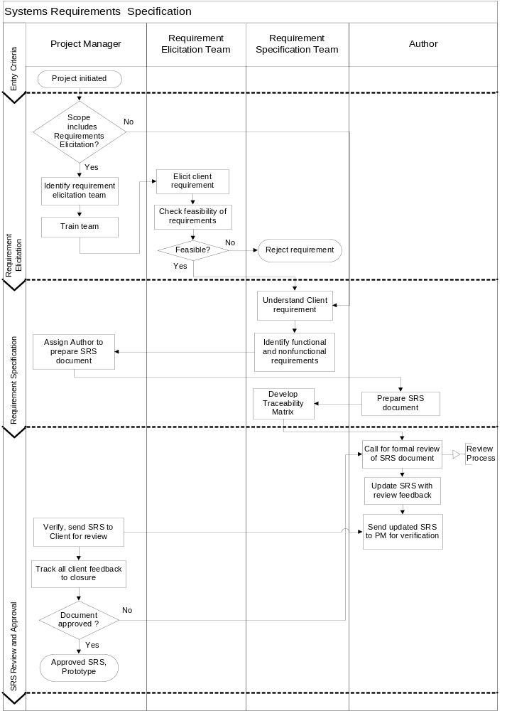
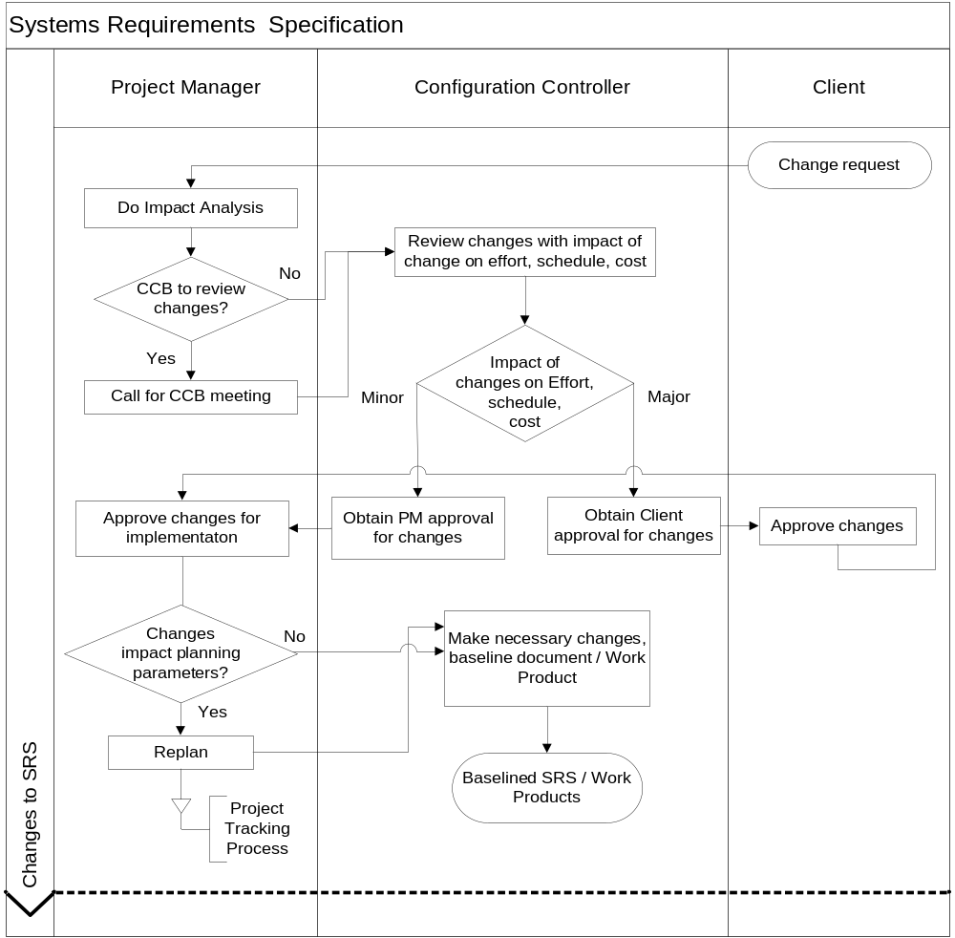

Process Description

Requirements Elicitation
- Requirements elicitation is executed if the scope of the project for Trianz includes gathering of requirements. Or requirements may be elicited if the requirements provided by the Client is not in detail
- Under such circumstances, PM identifies a team for Requirements Eliciting and apprises them of the guidelines to be followed for Requirements Elicitation
- The Requirements Elicitation team elicits Client requirements. Refer to Requirements Elicitation Guidelines document for more details.
- On analysis of the initial set of requirements the team validates the feasibility of the requirements from the point of design, construction, testing in the following ways and then proceed to accept or reject the requirements
  - Validate the requirements against SRS checklist
  - Simulate the to be built system using computer models and check for performance etc

Requirements Specification
The Requirement Specification team discusses a strategy for analysis and may do any or all of the following:
- Understand all requirement details available from the client in the form of various documents, Statement of Work, e-mails, etc
- Conduct a series of meetings with the Client to understand the requirements clearly, and record minutes of the meetings
- Identify a list of functional requirements of the software and non-functional requirements (like performance, maintainability, compatibility etc.)
- General requirements of users skill levels, constraints and assumptions etc. are understood
- Classify the requirements into various categories:
- Business Requirements
- Use cases or scenarios
- Business rules
- Functional requirements
- Non-functional requirements
- External Interface requirements
- Constraints
- Data Definitions
- Deployment Scenarios
For further details refer to Requirements Elicitation Guidelines.
- If a prototype is required, the team develops the same as part of this phase
- The PM then assigns an author to prepare the SRS document for the project
- The author may call for a meeting with the team members and concerned personnel (with domain knowledge) for discussion on the contents of the SRS
- At the discretion of the PM, the Client may also be invited to join these meetings
- The author then prepares the System Requirement Specification document using Systems Requirements Specification template for the project, and addresses all sections pertinent to the project.

Traceability Matrix
- Requirements specification team develops the Traceability matrix. Refer to Traceability Matrix template
- Traceability matrix is created as per the Traceability Matrix guidelines

SRS Review and approval
- The author coordinates for a formal review of the SRS Document as per the Review Process and SRS Review Check List
- PM makes sure SRS is reviewed and approved by the client. Refer to Review process for details on conducting reviews

Changes to SRS
- Whenever the Client requests changes to the requirements, the PM verifies the impact of the change
- The PM then may call for a CCB meeting
- The CCB reviews the changes along with the impact of the change on the effort, schedule and cost. Refer to Project Management Planning process and Project Tracking process for details on how to constitute CCB, how to log in, track and resolve Change Requests
- In case of major changes, changes that have an impact on the effort, cost, or milestone, Client approval is obtained before the changes are incorporated
- At the discretion of the PM, any minor internal changes identified to the requirements may be sent to the Client for a re-approval or baselined without Client approval
- PM verifies whether the approved CRs have any impact on the project objectives and the planning parameters. Under such circumstances PM initiates re-planning. Refer to Project Tracking process for details.

Outputs

Deliverables
- Approved System Requirements Specification document
- Notes and minutes from requirements elicitation
- Prototype, if available
- Change Log
- Traceability Matrix

Quality Records
Quality Record | Responsibility
SRS Review Report | PM
Approval of SRS by the client | PM
Change request approval | PM

Exit Criteria
- Project Closure

Process Assets
Document Number | Document Name
QMS/5101/0142 | Systems Requirements Specification Template
QMS/5101/0290 | Requirements Elicitation Guideline
QMS/5101/0054 | SRS Review Checklist
QMS/5101/0193 | Traceability Matrix

Measurement
- Defects found in a baselined SRS (Number of defects that can be traced to initial set of baselined requirements)
- Requirement Volatility (Number of changes received and Number of changes implemented, phase wise)

Tailoring Guidelines
Process Step | Tailoring provided | Remarks
Review of SRS by relevant stake holders before baseline of SRS | PM, may involve Client to reduce iteration of the SRS document
Updation of SRS while addressing CRs | The frequency of updation may be identified in the PMP if the changes are too many. | However updating SRS is mandatory at every phase completion
Creation and maintenance of SRS as an independent artifact | SRS may be combined with the design document, In case of small projects,
Absorption of changes without additional cost to the Client | Project Manager may define the maximum extent to which the additional costs due to changes may be absorbed by the project without an additional cost to the Client, with the approval of Director Delivery | All changes should be tracked to closure through the change log.

Standards Addressed
ISO 9001:2000
Clause |  | Description
7.2.1 |  | Determination of requirements related to the project
CMMI
Process Area | Specific Practice | Description
Requirements Management | SP 1.1 | Obtain an Understanding of Requirements
 | SP 1.2 | Obtain Commitment to Requirements
 | SP 1.3 | Manage Requirements Changes
 | SP 1.3 | Maintain Bidirectional Traceability of Requirements
 | SP 1.4 | Identify Inconsistencies between Project Work and Requirements
Requirements Development | SP 1.1 | Elicit Needs
 | SP 1.2 | Develop the Client Requirements
 | SP 2.1 | Establish Product and Product-Component Requirements
 | SP 2.2 | Allocate Product-Component Requirements
 | SP 2.3 | Identify Interface Requirements
 | SP 3.1 | Establish Operational Concepts and Scenarios
 | SP 3.2 | Establish a Definition of Required Functionality
 | SP 3.3 | Analyze Requirements
 | SP 3.4 | Analyze Requirements to Achieve Balance
 | SP 3.5 | Validate Requirements with Comprehensive Methods

Appendix
None

Revision History
Rev. No. | Author | Date | Reason for Change | Change Description
1.00 | Vandana M | 20 Sep ‘97 | None | None
7.01 | Anandi | 09 Oct 02 | Updation to 2000 standards | - Section 8 on Standards Addressed to reflect the clauses applicable to 2000 standards  - General formatting changes
8.00 | Anandi | 25 Oct 02 | Approval by Vandana M | - Baselined to version 8.00
8.01 | Vivek | 17 Dec 04 | Merger with Trianz | - Changed EximSoft name to Trianz
9.00 | Anandi | 22 Dec 04 | Review for baseline | - Approval for baseline
10.00 | Bala | 26 Oct 05 | Approved for baseline addressing CMMI Gaps | - Process policies modified  - Under process Description, "Requirements Elicitation process" added as a section  - Requirement analysis process modified  - The entire document is aligned to new process template
10.01 | Anandi | 04-Apr-06 | Review by QMG | - Addition to Measurement and Tailoring guidelines
11.00 | Balu Nair | 21-Apr-06 | Approved by Bala Raja | - Baselined

